Thank you for your interest in professional development in Music Education based on the philosophies and teachings of Hungarian musician and educator, Zoltán Kodály. The aural-vocal approach to teaching music that grew out of Kodaly’s philosophies is widespread and can be found in schools, universities and communities all over the world.

Catering for music specialists, classroom and studio teachers wanting to develop music literacy using an engaging and sequenced approach, the teaching pedagogy focuses on the voice as the primary instrument for learning and teaching. Incorporating games, movement, instruments, reading and writing music, the teaching sequence follows students’ natural learning development: listen – sing - understand – play/create - read and write – compose.

In 2019 we intend to offer courses in Primary and Secondary teaching as well as a Choir Course for students aged 8-13 years old. The pedagogy courses are appropriate for those teaching music in a range of contexts – classrooms, studios and/or community groups. The curriculum that is taught is that of the Australian Kodály Certificate (AKC), which is internationally recognised as an outstanding Kodály programme. It is a comprehensive course and involves a mixture of both hands-on and lecture-style tuition. The course is spread over 10 days and covers the following areas:

* Musicianship (Leveled classes): (15 hours)
* Methodology (Primary / Secondary) (15 hours)
* Teaching Techniques (5 hours)
* Cultural Materials (5 hours)
* Conducting (Leveled classes) (12.5 hours)
* Choir (10 hours)

**In 2019 the course will held at Iona College, Havelock North**

**Week 1: 12-18 April inclusive (7 days Friday to Thursday) Week 2: 1-3 June inclusive (3 days Saturday to Monday)**

Participants who complete the accredited course requirements for three levels in a pedagogy strand e.g. Primary Level 1, Level 2, Level 3, will be eligible to apply for the AKC. For more information on the Australian Kodály Certificate, please visit <http://www.kodaly.org.au/certificate.php>

Kodály Aotearoa and Project Prima Volta, in conjunction with The Cuskelly College of Music, will offer the programme as a two-part intensive course, allowing participants time to practise and complete assessment tasks between each block. Our tutors are amongst the best in their field internationally and have years of teaching this programme in Australia, Asia, New Zealand, USA and Hungary.

**Maree Hennessy** (San Francisco, USA) Master of Music Studies (University of Queensland), Bachelor of Education (Queensland University of Technology), Australian Kodály Certificate (KMEIA). Board member, NCAKE chapter of OAKE. Vice-President, KMEIA Australia.

Maree oversees the renowned Masters in Music Education (Kodály) programme at Holy Names University (Oakland, California). Maree has worked in music education across sectors and age groups - in early childhood, school, university and community settings. She is involved in teacher training in California, Australia, New Zealand and Asia.

Maree has been instrumental in the development of curriculum materials and resources designed to assist teachers in the implementation of effective music programs in schools. She enjoys working in mixed ability contexts when developing musicianship and has particular expertise and commitment to teacher development. Her work explores how reflective practice and collaboration can contribute to professional growth of teachers.

**Dr James Cuskelly (Brisbane, Australia)** is Head of Faculty: Creative Arts and Design Studies at St Aidan’s Anglican Girl’s School, Brisbane, President of the International Kodály Society, Director of the Summer School Music Programme, and Director of the Cuskelly College of Music. James has a very broad base in education, having taught in Kindergarten, pre-school, primary and secondary classrooms as well as in tertiary institutions. His passion for music, and his ability to enthuse and bring about effective learning in students across all ages or abilities, is internationally recognised. James is considered a global leader in music education and he directs internationally recognised programmes including the Summer School Music Programme (Brisbane) and Australian Kodály Certificate programmes in Malaysia, Perth and New Zealand and Indonesia.

Tutors



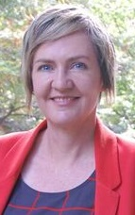

“On both a professional and personal level, this course was transformative and without doubt   
the most engaging, challenging and rigorous professional development I have done!”  
*Attendee, 2014*

**Kate Thompson** is an internationally recognised educator and clinician in Kodaly-based music education. She is frequently invited to be a guest presenter at conferences and workshops, most recently at the 2017 International Kodály Symposium (Canada), as well as Australian Kodály Certificate courses across Australia and in New Zealand. Kate has a passion for music education and community singing. She has taught Primary and Secondary classroom music at both state and independent schools and is currently the Primary Music Specialist at Ambrose Treacy College, Brisbane. She runs community musicianship classes for a variety of age groups for the Pathways to Music Programme and is conductor of Voices of Birralee ‘Kids’ and the assistant conductor of both the Queensland Kodály) Choir and the Birralee Blokes.

**Megan Flint** (M.Mus.(Hons), B.Ed., Dip. Tchg., ATCL(Voice))**,**has a background in education and music, as both a primary school teacher and music specialist.

Megan completed her Masters degree in Choral Conducting through The University of Auckland with Dr Karen Grylls. She is a practitioner of the Kodály methodology in music education, having completed her training through The Cuskelly College of Music, Australia. This forms the basis of her work as the music specialist at Royal Oak Primary School, teaching classroom music, instrumental ensembles and singing from Years 1-6. Megan is the co-author of *Hear Our Voices*, a handbook for leaders of children’s choirs and presents the successful national workshop series *Primary Gestures* for the NZ Choral Federation, as well as being a conducting mentor.

Tutors

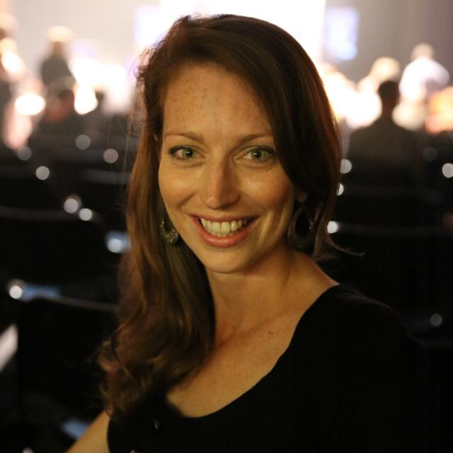

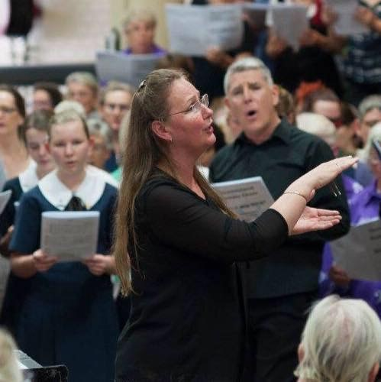

“On both a professional and personal level, this course was transformative and without doubt   
the most engaging, challenging and rigorous professional development I have done!”  
*Attendee, 2014*

**Provisional Course Timetable – subject to change**

**Block 1 Timetable**

|  |  |  |  |  |  |  |  |
| --- | --- | --- | --- | --- | --- | --- | --- |
| **Day 1-7** | 8.30-10.00  Musicianship | 10.00-10.30  Break | 10.30-1.00pm  Methodology | 1.00-2.00 Lunch | 2.00-3.15  Choir | 3.15-3.30  Break | 3.30-5.00  Conducting |

**Please note that Thursday 18 April will finish at 2.30pm. There will be a shortened lunch break (1.00-1.30pm) and then a performance by the children’s choir programme (1.30-2.30pm).**

**Block 2 Timetable**

|  |  |  |  |  |  |  |  |
| --- | --- | --- | --- | --- | --- | --- | --- |
| **Day 8-9** | 8.30-10.00  Musicianship | 10.00-10.30  Break | 10.30-1.00pm  Methodology | 1.00-2.00 Lunch | 2.00-3.00  Choir | 3.00-3.15  Break | 3.15-4.30  Conducting |

|  |  |  |  |  |  |
| --- | --- | --- | --- | --- | --- |
| **Day 10** | 8.30-10.00  Musicianship | 10.00-10.30  Break | 10.30-12.00  Methodology | 12.00-1.30  Sharing time/Choir/Certificates/Farewells | Shared lunch for those interested |

“Let us take our children seriously! Everything else follows from this…only the best is good enough for a child.”  
*Zoltán Kodály*

**If I’m interested, what do I do?**

**In 2019 the course will held at Iona College, Havelock North**

**Block 1: 12-18 April inclusive (7 days Friday to Thursday) Block 2: 1-3 June inclusive (3 days Saturday to Monday)**

**First:**

Decide on the programme / module you would like to do. There are two pathways – assessed (for credit towards Australian Kodály Certificate) or audit. Module courses (Taster days, Musicianship and Conducting/Choir streams) are only audit courses. If this is your first time undertaking a Levels course, you will start at Level 1 (Primary or Secondary).

**Programmes/Modules offered in 2019:**

Primary Level 1

Primary Level 2

Secondary Level 1

Taster days – Saturday 13 and Sunday 14 April

Musicianship only

Choir and Conducting only

Kodály Kids Course – full days (Monday 15 April –Wednesday 17 April 8.30-5.00; Thursday 18 April 8.30-2.30)

Kodály Kids Course – half days (Monday 15 April –Wednesday 17 April 8.30-1.00; Thursday 18 April 8.30-2.30)

*NB: Compulsory textbooks are required for coursework (except Kodály Kids Course*)*.*

**Then:**

Complete the registration form (separate form for Kodály Kids Course) and submit to Megan Flint [meganjude@xtra.co.nz](mailto:meganjude@xtra.co.nz)

Or contact course convenor Megan Flint to discuss your options [meganjude@xtra.co.nz](mailto:meganjude@xtra.co.nz) / 0272462062

**Please contact Megan for further information or to arrange a visit to a classroom where the Kodály pedagogy is in practice.**

**Come and see for yourself how empowering the methodology is for both students and teachers!**

**Like us on Facebook to stay up-to-date ‘Kodály Aotearoa’**

